

Tourism Management System

By

Kommuri Venkata Sai Nikesh

700647219

University Of Central Missouri

**Abstract**

Now a day’s number of people, using internet is increasing exponentially, so the use of web applications is also increasing. This is a proposal to design a web application for booking a package for Tourists.

Tourism Management System is a web application which gives information on packages available to the users, the user has to register/login the web application and select the package and book the package for a particular date. The user can change the package or cancel the package at any time. User can also change the date of the package. The user can select the food they want to eat from the menu and they can modify the items or can delete the items.

This web application will help the user to save time and money. Many of them spend their time by visiting the office and gather information, discuss with the people and pay the money. By this application user can directly see the packages from his place without visiting any office and wasting their time.

Table of Contents

Introduction 3

Project Description 3

User: 3

Admin: 4

System used and specification 5

Hardware and Software used 5

Technology used 5

Use Case List 6

Use Cases 7

High Cut use case diagram for site 7

Use Case Specification for high cut use case 8

DoSignIn Use Case diagram 9

Use Case Specification for DoSignIn 9

Select Package use case diagram 10

Use Case Specification for Select Package 11

Add Package Use Case Diagram 12

Use Case Specification for Add Package 12

Activity Diagram 14

High Cut Activity Diagram 14

Select Package Activity Diagram 15

ER Diagram 16

Class Diagram 17

Sequence Diagram 18

User Sequence Diagram 18

Admin Sequence Diagram 19

Collaboration Diagram 20

User Collaboration Diagram 20

Admin Collaboration Diagram 20

Test Cases: 21

Scenario Level Testing: 21

# Introduction

Tourism management system is a good application for booking tickets to travel. In old days we don’t have any technology so we should go to the nearest retailer but now a days we no need to go anywhere we can book anything at the same place where we are. The functionalities used in this application are

|  |  |
| --- | --- |
| **Admin** | **User** |
| Add Package | Book Package |
| Add Room | Book Room |
| Add Food | Book Food |
| Add Transport | Book Transport |
| Update / Delete Package | Modify / Cancel Package |
| Update / Delete Room | Modify / Cancel Room |
| Update / Delete Food | Modify / Cancel Food |
| Update / Delete Transport | Modify / Cancel Transport |
| Add Discount | Confirmation Details |
| Update /Delete Discount | Payment |

# Project Description

This site helps the user to book any kind of package they want. The packages are the displayed in a table according to the packages name selected by the user. The total usage scenario is explained below by category wise. The site has two kind’s usages user and admin

## User:

1. User should register to the site with all the required details. And then he/she can login to the site. User can also reset their password if they registered already.
2. User can search for the packages which were added by the admin. He/ she can view the packages with place in a table by selecting any package name displayed in the dropdown box.
3. User can book their food, transport and room only if they book any package in the site. If they don’t book any package then they cannot book any of the things listed above.
4. User can view different types of room and size of room by selecting the hotel name. Coming to food they can book any kind of food by selecting type of food they want. Similarly they can book there transport by selecting the mean of transport they want to travel.
5. User can view there packages, food, room and transport they have booked and they can modify / cancel them according.
6. Finally they can view their conformation page where they can see the total cost of the package that is sum of package cost, room cost, food cost and transport cost so that they can pay the total money.
7. In this payment they will get 10% discount for their first package and 30% discount for their 3rd package. In additional to the 10% for the 1st package they can get any additional discounts if available for the selected package which are added by admin.

## Admin:

1. Admin can add packages he/she want. While adding the package he should give the package name, place, number of days, cost. If he/she add same package name with same place the package will not be added if admin add same package name but different place then it will be added.
2. Admin should add hotels first so that he/she can add rooms later with respective to the hotel name. In room admin should add type and size of the room and finally cost of the room.
3. Admin can also add the food by selecting which type of food he want to be added.
4. Finally he/ she can also add the transport like which type of vehicle user may need.
5. Admin can update/delete the package, room, food and transport which was added by him/her.
6. He/she can add the percentage of discount for any package which was selected by user as his/her 1st package.
7. Admin can also update the discount program like changing the discount percentage or deleting the discount.
8. He/she can view all the payment details finally made by the users.

# System used and specification

## Hardware and Software used

Processer : Intel i5

RAM : 8 GB

Operating System: Windows

## Technology used

Database : MYSQL

IDE Tool : Eclipse neon

Technologies: Servlets, JSP, JavaScript, JQuery, Ajax, Boot strap, HTML5, CSS

# Use Case List

|  |  |  |
| --- | --- | --- |
| **Use Case ID** | **Primary Actor** | **Use Cases** |
| 01 | User, Admin | DoSignIn  Modify Details  Select Package  Payment  Confirmation details  Add Package |
| 02 | User | Display Registration  Sign up  Approve User  Login |
| 03 | User | Select Package  Modify Package  Select Room  Modify Room  Select Food  Modify Food  Select Transport  Modify Transport |
| 04 | Admin | Add Package  Update Package  Add Room  Update Room  Add Food  Update Food  Add Transport, Update Transport |

# Use Cases

## High Cut use case diagram for site

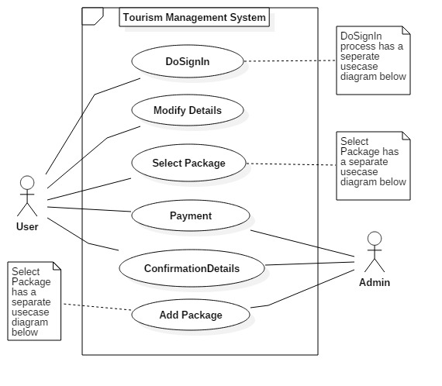

**Note:**

In this use case we can see from user side and from admin side as the high cut side and we can see the add package use case separately for user and admin. He also can see the do sign in use case from user separately.

## Use Case Specification for high cut use case

|  |  |  |  |  |
| --- | --- | --- | --- | --- |
| **Use Case ID:** | 01 | | | |
| **Use Case Name:** | High Cut | | | |
| **Created By:** | Nikesh Kommuri | | **Last Updated By:** | 02-28-2017 |
| **Date Created:** | 12-15-2016 | | **Last Revision Date:** | 02-28-2017 |
| **Actors:** | | User, Admin | | |
| **Description:** | | User clicks on the login and start viewing his own details if he wants to change the details if needed and view the packages he want. User goes to payment after selecting his package | | |
| **Trigger:** | | Whenever user clicks on the login button this use case will be triggered | | |
| **Preconditions:** | | **User should be registered to the site** | | |
| **Postconditions:** | | User can modify his/ her package if needed | | |
| **Normal Flow:** | | 1. User login to the page 2. User Select the package he / her needed and view the details of the package in the table form 3. Admin displays the confirmation page to the user and generate the discount 4. User goes to payment page | | |
| **Alternative Flows:** | | 1a. if User gives in valid details the page gives invalid message | | |
| **Frequency of Use:** | | If User wants to book any package | | |

## DoSignIn Use Case diagram

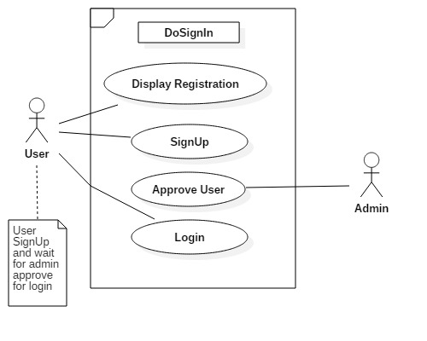

## Use Case Specification for DoSignIn

|  |  |  |  |  |
| --- | --- | --- | --- | --- |
| **Use Case ID:** | 02 | | | |
| **Use Case Name:** | DoSignIn | | | |
| **Created By:** | Nikesh Kommuri | | **Last Updated By:** | 02-28-2017 |
| **Date Created:** | 12-15-2016 | | **Last Revision Date:** | 02-28-2017 |
| **Actors:** | | User, Admin | | |
| **Description:** | | User wants to register to the site to book any package he wants | | |
| **Trigger:** | | When user clicks on register button this use case will be triggered | | |
| **Preconditions:** | | **User should open the site and should know teams and conditions of the site** | | |
| **Postconditions:** | | User can login to the page and can book package | | |
| **Normal Flow:** | | 1. User Should give the correct details in the required files 2. User should click on the register button | | |
| **Alternative Flows:** | | 1a. if user gives in valid details then he/her cannot register to the site  If user register again with the same email id then he cannot register to the site | | |
| **Frequency of Use:** | | Only once if User wants to book any package for travel | | |

## Select Package use case diagram

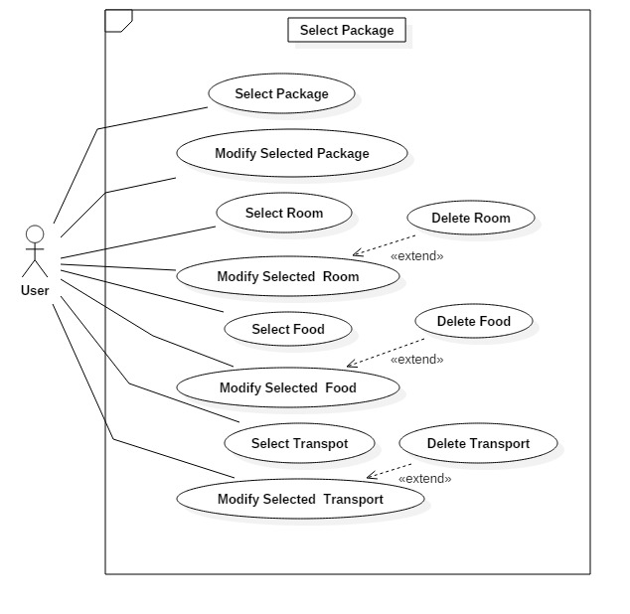

## Use Case Specification for Select Package

|  |  |  |  |  |
| --- | --- | --- | --- | --- |
| **Use Case ID:** | 03 | | | |
| **Use Case Name:** | Select Package | | | |
| **Created By:** | Nikesh Kommuri | | **Last Updated By:** | 02-28-2017 |
| **Date Created:** | 12-15-2016 | | **Last Revision Date:** | 02-28-2017 |
| **Actors:** | | User | | |
| **Description:** | | User can view all the packages and he can book any package he wants  User can also book room, food, transport for the package he/her booked  User can also modify / cancel he/her booked | | |
| **Trigger:** | | When user clicks on select package this use case will be triggered | | |
| **Preconditions:** | | **User should login with correct details** | | |
| **Postconditions:** | | User goes to confirmation page for payment for the travel package | | |
| **Normal Flow:** | | 1. User selects package he/her wants. 2. User views all the room type, different types of food and mean of transport. 3. User selects all the above. | | |
| **Alternative Flows:** | | User can Modify the selected package , room, food, transport | | |
| **Frequency of Use:** | | Whenever User wants to book travel package and modify them | | |

## Add Package Use Case Diagram

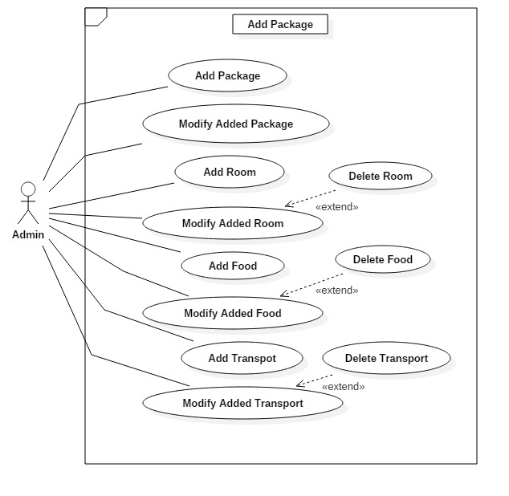

## Use Case Specification for Add Package

|  |  |  |  |  |
| --- | --- | --- | --- | --- |
| **Use Case ID:** | 04 | | | |
| **Use Case Name:** | Add Package | | | |
| **Created By:** | Nikesh Kommuri | | **Last Updated By:** | 02-28-2017 |
| **Date Created:** | 12-15-2016 | | **Last Revision Date:** | 02-28-2017 |
| **Actors:** | | Admin | | |
| **Description:** | | Admin can add different types of packages accordingly with place name and admin can also add different types of room, food, and transport  Admin can also modify /delete the package, room, food and transport | | |
| **Trigger:** | | When admin clicks on add package this use case will be triggered | | |
| **Preconditions:** | | **Admin should get all the details of the package such as package name, place, no of days, cost of the package, similarly admin should also gather details regarding room, food, transport** | | |
| **Postconditions:** | | Admin can modify the package, food, room, transport he/her added | | |
| **Normal Flow:** | | 1. Admin Should enter the package details in the required fields 2. Admin adds other details like room, food, transport 3. Admin clicks on add package | | |
| **Alternative Flows:** | | 1a. if package is already added it displays error message about the package already existed | | |
| **Frequency of Use:** | | Whenever admin wants to add any new package this use case is used | | |

# Activity Diagram

## High Cut Activity Diagram

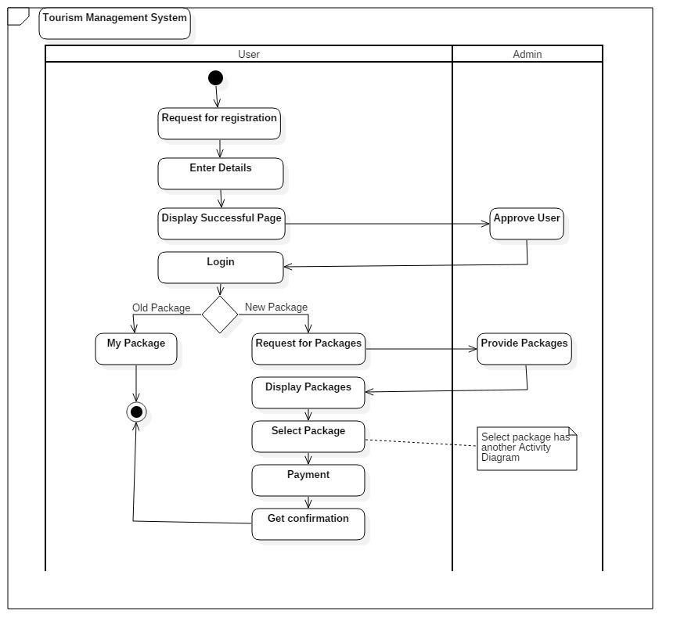

## Select Package Activity Diagram

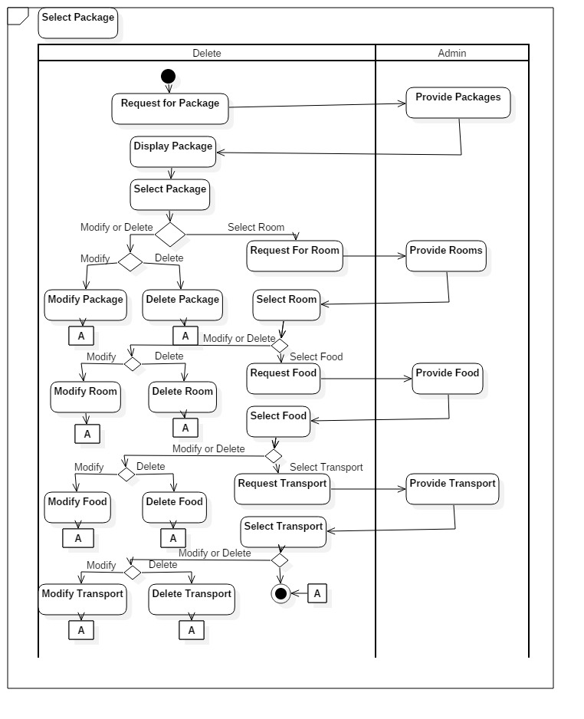

# ER Diagram

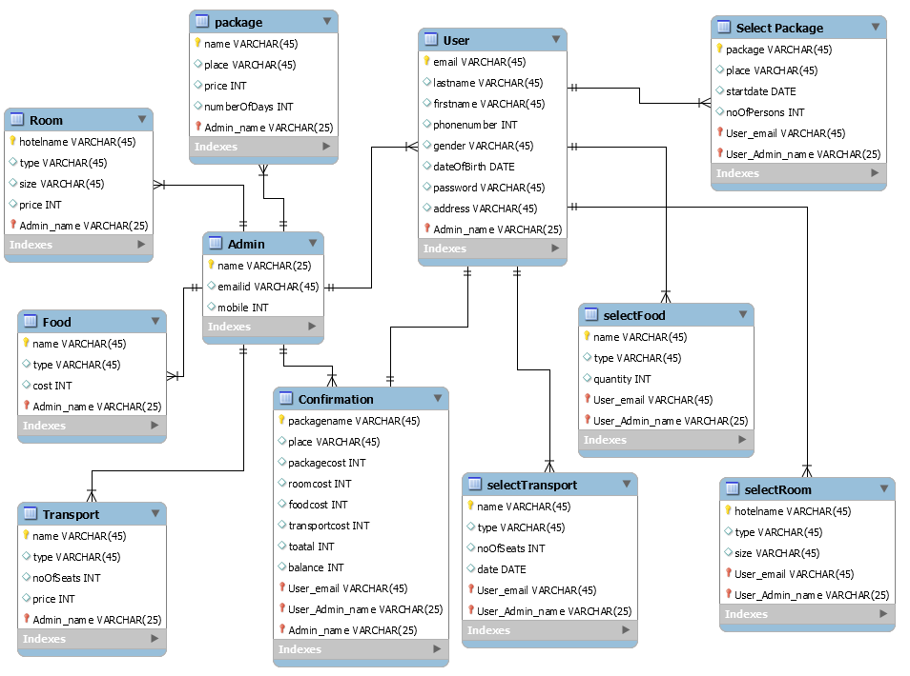

**User**: this stores the data of user information

**Package**: stores the data of all the packages added by admin

**Food**: stores all the data of food added by admin

**Room**: stores the data of all the rooms added by admin

**Transport**: stores all the data of transport added by admin

**Confirmation**: stores all the payment details of all users

**Selectpackage**: stores all data of selected packages by all users

**Selectfood**: stores all data of selected food by all users

**Selectroom**: stores all data of selected room by all users

# Class Diagram

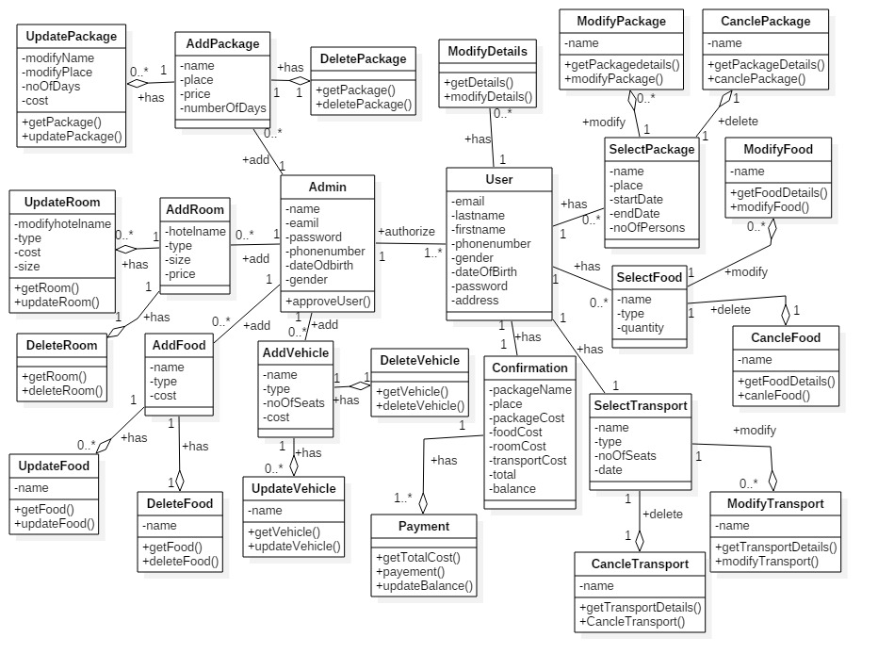

# Sequence Diagram

## User Sequence Diagram

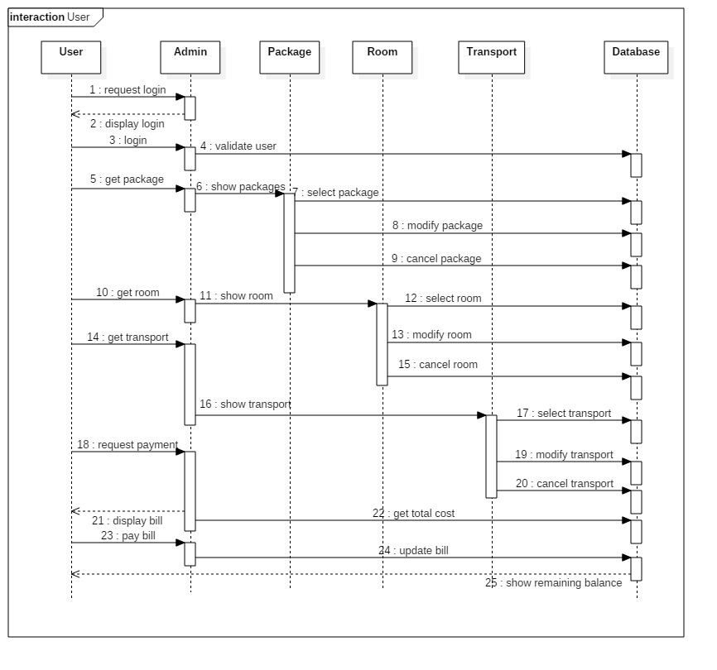

## Admin Sequence Diagram

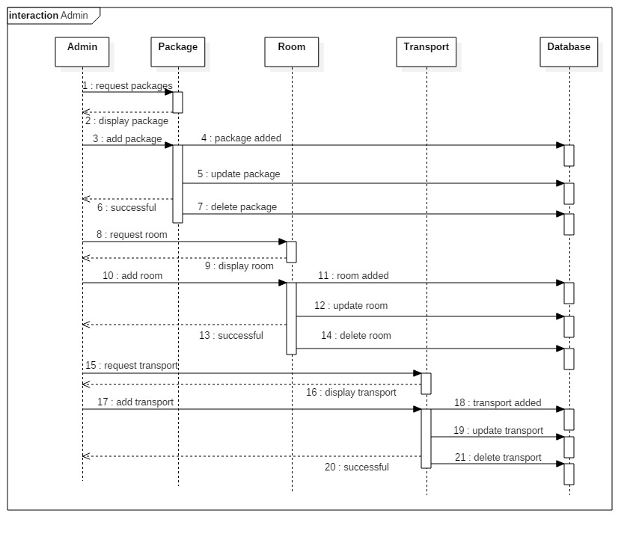

# Collaboration Diagram

## User Collaboration Diagram

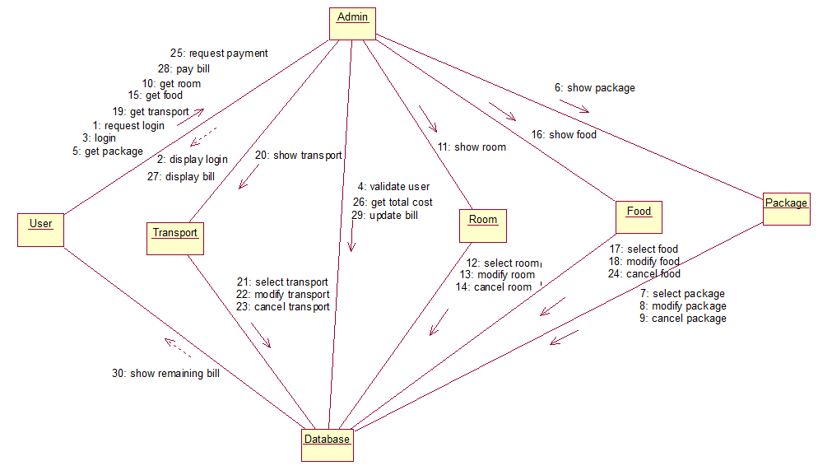

## Admin Collaboration Diagram

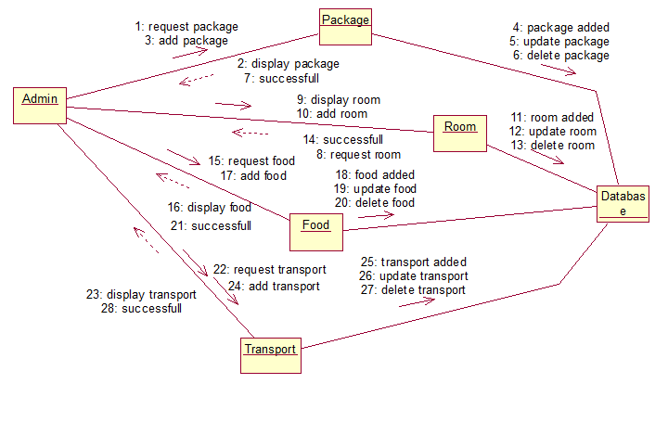

# Test Cases:

|  |  |  |  |
| --- | --- | --- | --- |
| **Case Number** | **Description** | **Result** | **Passed** |
| 01 | Register on to the system as a user with the required fields such as name, email, mobile and password | User used get registered if email he/her entered is not registered previously and if it is registered it should display some error message | Yes |
| 02 | Login on to the System when user enter the required details like email and password | User enters the required fields and clicks on login if the entered details are correct then user should go to user home page, if user did not enter correct details then error message should be displayed | Yes |
| 03 | Getting discounts for 1st package for every user when he goes for payment | When user goes for payment the system should check that the user is paying for 1st package or not, if user is paying for 1st package then user should get 10% discount on his total amount, if not he should not get any discount. | Yes |

# Scenario Level Testing:

Testing for selecting a package by user.

Testing Procedure:

1. Click on login from the home page to view login page
2. Login credentials are email: [nikesh2804@gmail.com](mailto:nikesh2804@gmail.com) password:8121343348
3. On the user home page you can view select package category by click on that we can see select package drop down box
4. By selecting the package we can view all the packages with same name but different places and corresponding details

I have implemented the above scenario as

**Controller**: BookPackage

**Function:**

When user login then user.jsp file will be appeared and then by clicking on the select package it will redirect to package.jsp which is located in user package. After selecting the package name then the bookpackage controller gets all the package from DB and get the package’s which are with package name selected by user and throws them back to the table with all details into the same page with the help of ajax and jQuery.